2019

Summer Beginning Band Camp
  - Johnson City Schools
Instrumental Music Program
ITIS - LBMS - SHHS
Summer Beginning Band Camp: June 10-14, 2019 |  |  |  |  |  | Student Registration Form:  Student’s Name: _________________________  Instrument: ________________________________  Parent/Guardian’s Name: ______________  Address: _______________________________  _______________________________  Phone Numbers: Home _____________________  Cell _______________________  Work ___________________  E-mail Address: _____________________________ ____________________________________________  To register, please complete and return this form by Tuesday, May 28th, 2019 to:
 | Camp Registration Fee: $30  (Will be collected on Sunday, June 9th during activity registration @ 2 p.m.)  Location: SHHS Band Room  Daily Schedule (June 10th -14th ) :  8:30-9:00am: check-in  9:00-12:00pm: Individualized Instruction  12:00pm: check-out  Optional Activities:  12:00-12:30pm: Lunch (bring bag lunch)  12:30-3:30pm: Varied Social Activities  Examples ($):  - Masterpiece Mixers  - Kingsport Aquatic Center  - Movie  - Quantum Leap  Students must provide their own instruments to participate in this camp.  If you have any questions, contact:  Keila Brady Tidwell, ITIS Band Director  bradyk@jcschools.org |  |  |  |  | 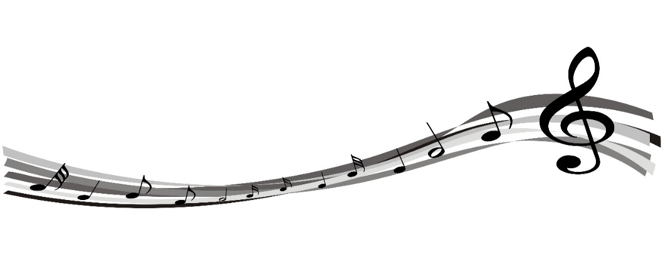  Keila Brady Tidwell  Indian Trail Intermediate  307 Car-Mol Dr.  Johnson City, TN 37601

